Meeting in Estonia (C1) 19.05.-25.05.2017
Land art and outdoor learning
Fr 19.05 Arriving to Tallinn
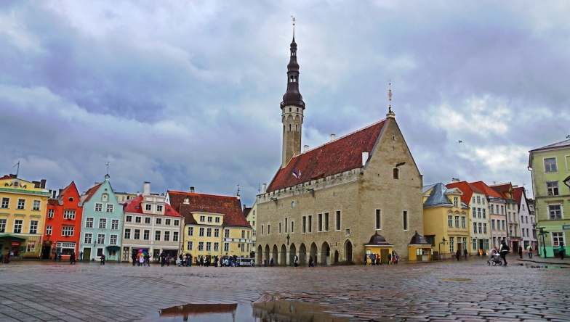 Town Hall square
Sat 20.05
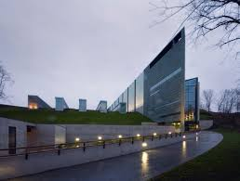
9.15 getting together by Toompea
9.30 A small sightseeing in Tallinn (old town)
10. 30 A coach will take us to KUMU ( Art museum), where we have an excursion in two groups:
90 minutes tour for teachers
60 minutes tour + 30 minutes workshop for students (conducting colors in modern art style)
13.00 Lunch in KUMU (11,50)

14.30 Leaving for Tartu. It will take about 2 and half hours ( a coach).
17.00 Accomodation in the hostel of Tartu University, Raatuse 22.
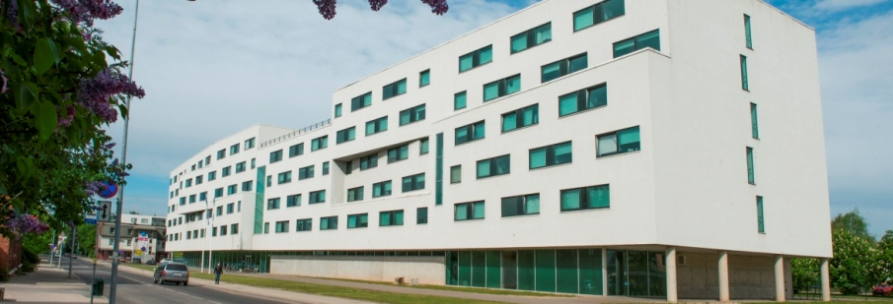

Free evening. We can go to supermarket to buy something for breakfast or I will show you a breakfast place in town for the mext morning.

Sun 21.05
9.30 Leaving for ERM (Estonian National Museum) by foot. 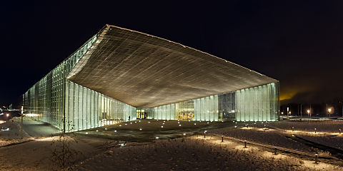
10 – 11.30 tour in museum
11.30 – 12. 15 workshop (family signs; every student can make a token with his/her family sign, using woodburn pencil; one teacher is needed for every country to assist students)
12.30 Lunch in ERM (4 – 6 eur?)
Some rest.
15.00 from hostel: walking in Tartu. I will show you some nice places.

Free evening
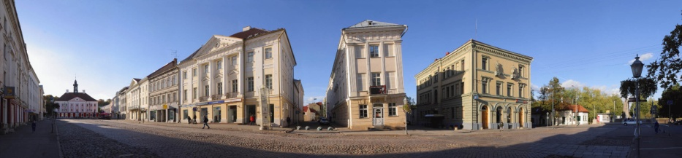

Mon 22.05
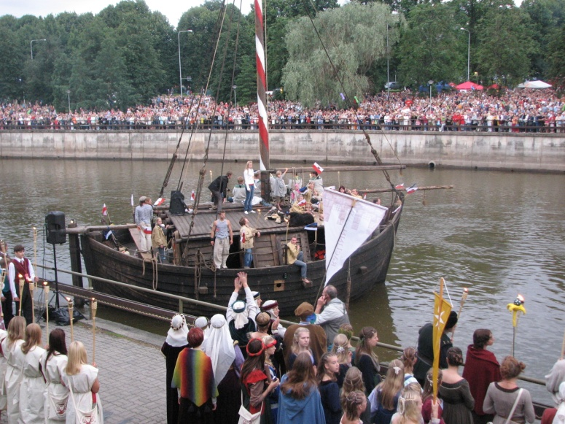
9.30 leaving for harbor
10.-11.30 Cruise on the ancient boat JÕMMU on the river Emajõgi. Outdoor learning. Teachers can have a small meeting about project matters on the board.
Jõmmu
12.30 Lunch in Dorpat buffee. (Soup and salad buffet 5.00€ ; Full buffet 7.50€)
http://www.dorpat.ee/tartu-restaurant/
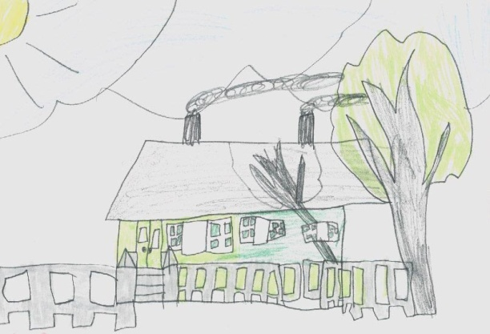
14.00 Leaving for Unipiha school (the coach)
14.30 – 17.00 Getting acquinted with Unipiha school and students.
Two workshops: 1) picture of clay 2) sand art
17.00 back to Tartu and free evening.
Erasmus meeting (for teachers)

Tue 23.05
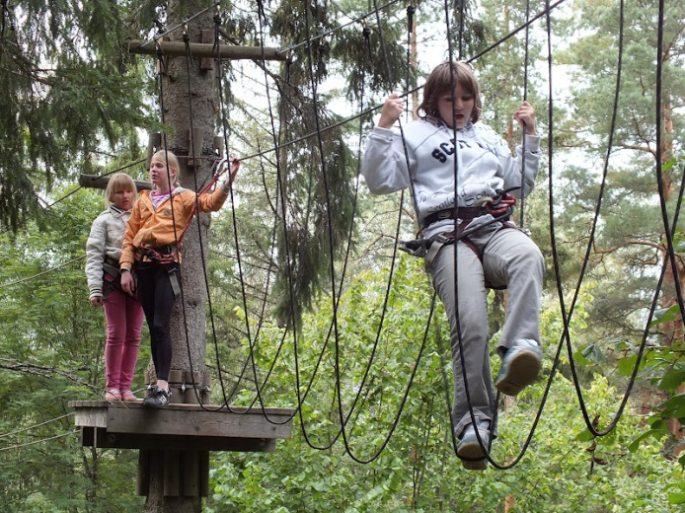
11.00 Leaving for Otepää (the coach)
12.30-15.30 adventure park (sportswear is needed) in Otepää – outdoor activities
http://www.seikluspark.ee/en/seiklused-rajad-eng

16.00 Lunch in Otepää (Tehvandi cafe buffet about 6 eur)
Leaving for Tartu
Free afternoon

Wen 24.05
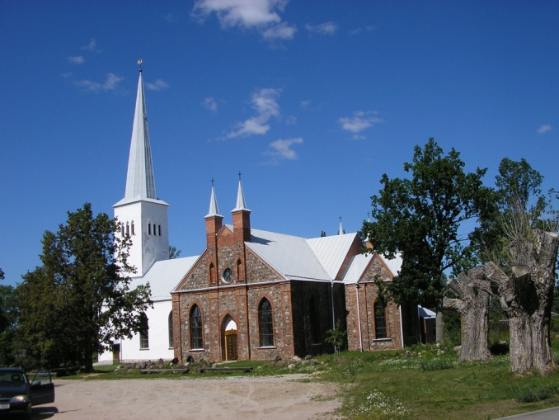
9.30 Check out the hostel. Put your luggage to the coach. Leaving for Kambja (25 km-s, the center of commune).
10.-10.30 meeting the head of Kambja county
10.30 – 11.15 Kambja church and some other places.
11.15.- 12.00 Tour in Kambja school.
12.15.- 13.00 Workshop (lyre) for students
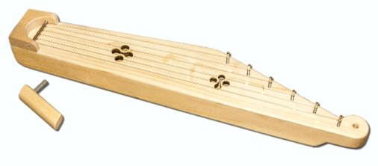

12.15- 13.00 Erasmus meeting (for teachers)
13.00 Lunch at Kambja school cantine.
14.00 Concert in the school hall.
Final party with dances and games. Here is the place where every team can contribute:
- Some poem or song from each country in their language – to notice the different languages
- Project hymn (Hara!)
- We are going to teach some dances and you are welcome to teach your’s (please – the simpliest ones!)
Handing over the gifts.
Snack bar.

16. 00 Leaving for Tallinn straight from Kambja.

Thur 25.05
Leaving for home.

We will pay for museums and workshops; cruise and adventure park; lunch on 23.05 and snacks .

You will pay for accomodations, lunches outside the school and local transportation (Tallinn-Tartu; Tartu-Unipiha-Tartu; Tartu – Otepää-Tartu; Tartu-Kambja-Tallinn) 35 euros per person. You will get all the the receipts.

